
Tutorials Without Graphics
Table of Contents
Benefits Of Tutorials Without Graphics 1
Use In A Teacher-Student Setting Or In A Self-teaching Setting 2
Teacher-student Setting 2
Self-teaching Setting 2
Create A Tutorial From A Template 2
Use Copy and Paste 2
Write A New Tutorial From Scratch 3
Use A Numbered Outline 3
Modify The Heading Of Each Section 3
Modify/ Apply The “Title” Paragraph Style 3
Modify The “Heading 1” Paragraph Style 4
Modify The “Heading 2” Paragraph Style 4
Modify The “Heading 3” Paragraph Style 5
Paragraphs Under The Heading May Be Numbered Or Unnumbered. 5
Insert A Table of Contents And Add Hyperlinks 6
Create A Table Of Contents 6
Add Hyperlinks to the Table of Contents 6
If you have NOT inserted a Table of Contents 7
If you have already inserted the Table of Contents 8
Insert A Footer 9

We accept and appreciate tutorials from volunteers in whatever form they choose. This tutorial is about the benefits, use, and creation of tutorials without using graphics.

Benefits Of Tutorials Without Graphics
- Faster download from the Internet.
- Easier and faster to write a tutorial.
- Easier and faster posting to the website.
- A customized tutorial for a particular situation may be “patched” together by using Copy and Paste.

Use In A Teacher-Student Setting Or In A Self-teaching Setting

Teacher-student Setting
- In the teacher-student setting, the teacher may:
  - Read the tutorial exactly as written
  - Make copies of the tutorials for distribution
  - Use visual aids.
- There will be step-by-step instructions and explanatory information about the steps.
- “Teacher aides” circulating in the room are helpful.
- The student will do the steps and observe the results on the computer screen.
- The student may look at the computer screen as explanatory information is read.

Self-teaching Setting
In the self-teaching setting, there is no teacher. The student downloads a tutorial from the website or obtains a printed copy of a tutorial. If no printer is available, open the tutorial in OpenOffice and follow the on-screen directions. The student may:

- Read the tutorial
- Do the steps
- Observe the results
- Read the explanatory information.
Beginner users will use the entire tutorial. Advanced users may skim the tutorial and skip some parts.

To ask questions, please E-Mail this website. (See Note at end of tutorial

Create A Tutorial From A Template
One method is to use the Author's Template which is on the website. Another method would be to download a tutorial from the website and use it as a “template” which already has the formatting.

Use Copy and Paste
Other tutorials may be downloaded so that Copy and Paste can be used to combine information from several sources. The advantages of Copy and Paste are:

- Errors are eliminated.
- Words and phrases are used that have been improved by usage in other tutorials.
- Writing is easier/faster when some material has already been created for you.
- Learning from the tutorial is easier/faster with standardized words and phrases used in all the tutorials.

Write A New Tutorial From Scratch
It is assumed that the default settings (that are determined when the “Standard” installation is selected during the download/setup procedure of OpenOffice) are still in effect. An unnumbered introduction telling the purpose of the tutorial would be helpful.

Use A Numbered Outline
A numbered outline may be used.
- Click Format > Bullets and Numbering > Outline tab.
- Click the second choice on the top line of choices and click OK. (The number 1. appears.)
- If the Tab key is pressed, an a) appears.

Modify The Heading Of Each Section
The "Title" Paragraph Style is meant to be the title of the tutorial. The "Heading 1" Paragraph Style is used for the heading of sections. The "Heading 2" and "Heading 3" Paragraph Styles are used for the subheading of sections. After modifying the heading settings in your document, just double-click on the heading in the Styles and Formatting window to activate the Paragraph Style.

Modify/ Apply The “Title” Paragraph Style
- Open a new text document. Click File > New > Text Document. ( appears.)
- On the first line of the page, type the name of the tutorial and leave the cursor on that first line.
- Click Format > Styles and Formatting. (The "Styles and Formatting" window appears.)
- Click the Paragraphs Styles, icon (if the "Paragraph Styles" menu is not already there). (The "Paragraph Styles" menu appears. The list of words in the window is the names of Paragraph Styles that are available for use with paragraphs.)
- Click on the in the menu box at the bottom of the Paragraph Styles window . Scroll to and select “Chapter Styles”. (The "Chapter Styles” window appears.)
- Right-click Title. (A small menu 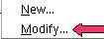 appears.)
- Click Modify. (The "Paragraph Style: "Title" window appears.)
- Click the Alignment tab. In the Options section, click Center if it is not already selected. (A dot appears before the word “Center”.)
- Click the Font tab. If it is not already selected/highlighted, click Arial ("Font) > Bold ( “Typeface”) > 16pt. (“Size”). Click OK.
- In the Styles and Formatting window, double-click Title. (The title of your tutorial is centered, is in bold, and the typeface and size is "Arial 16 pt". When any Paragraph Style with the word Title in its name is activated and the Enter key is pressed, the cursor stays in the center of the page and the Paragraph Style, Subtitle is activated. If you choose not to use a Subtitle, click Enter twice to activate the Text body Paragraph Style and then the cursor will move down two lines and the Paragraph Style named Text body will be activated. Text Body has the font name, "Arial”, the font size, 12 (in the "font size" menu box) and the "Bold", , icon, is no longer highlighted and is not in use.)

Modify The “Heading 1” Paragraph Style
Use the “Heading 1” Paragraph Style as the heading of each section.
- Click Format > Styles and Formatting. (The "Styles and Formatting" window appears.)
- Click the Paragraphs Styles icon (if the Paragraph Styles menu is not already there). (The "Paragraph Styles" menu appears. The list of words in the window is the names of Paragraph Styles that are available for use with paragraphs.
- Right-click Heading 1. Click Modify. (The "Paragraph Style: Heading 1" window appears.)
- Click the Alignment tab. In the Options section, click Center. (A dot appears before the word “Center”.)
- Click the Font tab. If it is not already selected/highlighted, click Arial ("Font) > Bold ( “Typeface”) > 16 pt. (“Size”). Click OK. (The "Paragraph Styles: Heading 1" window closes.)
- Type the name of the section. In the Styles and Formatting window, double-click Heading 1. (The section heading is centered and is in bold. The typeface is "Arial" and the "Size" is 16 pt". )
- Press the Enter key. (The cursor moves down two lines. “Text Body” is the Paragraph Style.)

Modify The “Heading 2” Paragraph Style
Use the “Heading 2” Paragraph Style as the heading of each section used to add information about the “Heading 1” Paragraph Style section.
- Click Format > Styles and Formatting. (The "Styles and Formatting" window appears.)
- Click the Paragraphs Styles icon (if the "Paragraph Styles" menu is not already there). (The "Paragraph Styles" menu appears.)
- Right-click Heading 2. Click Modify. (The "Paragraph Style: Heading 2" window appears.)
- Click the Alignment tab. In the Options section, click Left. (A dot appears before the word “Left”.)
- Click the Font tab. If it is not already selected/highlighted, click Arial ("Font) > Bold ( “Typeface”) > 14 pt. (“Size”).
- Click the Indent & Spacing tab. In the Indent section, in the “Before text” dialog box, type .50. Click OK. (The Paragraph Styles: Heading 2 window closes.)
- Type the name of the section that gives information about the Heading 1 section. In the Styles and Formatting window, double-click Heading 2. (The section heading is indented ½ inch and is in bold. The Typeface is "Arial" and the “Size” is 14 pt".)
- Press the Enter key. (The cursor moves down two lines. “Text body” is the Paragraph Style.)

Modify The “Heading 3” Paragraph Style
Use the “Heading 3” Paragraph Style as the heading of each section used to add information about the “Heading 2” Paragraph Style section.
- Right-click on Heading 3 then click the Modify button.
- Click the Alignment tab. In the Options section, click Left.
- Click the Font tab. If it is not already selected/highlighted, click Arial ("Font) > Bold ( “Typeface”) > 14 pt. (“Size”) > OK.
- Click the Indent & Spacing tab. In the Indent section, in the “Before text” dialog box, type 1.0. Click OK. (The Paragraph Styles: Heading 3 window closes.)
- Type the name of the section that gives information about the Heading 2 section. Double-click Heading 3. (The section heading is indented 1 inch and is in bold. The Typeface is "Arial" and the “Size” is 14 pt".)

Paragraphs Under The Heading May Be Numbered Or Unnumbered.

- Highlight the paragraphs under each section.
- Click on the Numbering On/Of , , icon, . (Numbers appear before the paragraphs under each heading.)
- When finished with the last paragraph under each Heading, place the cursor after the last word of the last paragraph and press Enter. (The cursor will move down to a new paragraph. If a number appears, click the “Numbering On/Off” icon to delete the number.)

Insert A Table of Contents And Add Hyperlinks
If you would like to do so, you may create a Table of Contents and add hyperlinks..

Create A Table Of Contents
- After completing your tutorial, click after the last word in the title which is the first line of the tutorial. (The flashing cursor, appears after the last letter in the last word in the title.)
- On the menu bar, click Insert. Click Indexes & Tables >Indexes & Tables. (The “Insert Index/Table” window appears.)
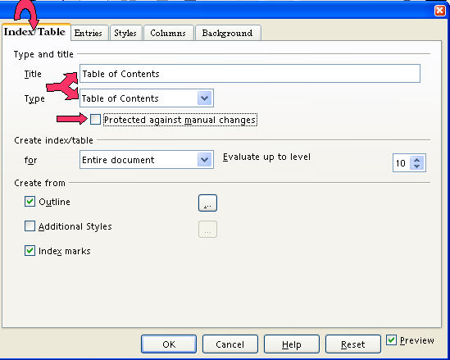
- Select the Index/Table tab, if it is not already selected. In the “Type” dialog box , select Table Of Contents, if it is not already selected. Uncheck Protected against manual changes. Click OK. (A "Table of Contents" appears at the beginning of your tutorial under the title.)

Add Hyperlinks to the Table of Contents
When a word(s) in the "Table of Contents" is clicked, the cursor will go to where that information is found. For example. “Add Hyperlinks to the Table of Contents” will be in the "Table of Contents" in this tutorial. In the "Table of Contents", click the words, “Add Hyperlinks to the Table of Contents”. The cursor will go to this section on this page.

If you have NOT inserted a Table of Contents
- Click after the last word in the title of the document. On the menu bar, click Insert. Click Indexes & Tables >Indexes & Tables. (The “Insert Index/Table” window appears.) Select the Index/Table tab, if it is not already selected. In the “Type” dialog box , select Table Of Contents, if it is not already selected. Uncheck Protected against manual changes.

- To make the hyperlinks, click the Entries tab of the window. Click to the left of the E and click Hyperlink. Click after the E and click Hyperlink again. Click All. Click OK. (The "Table of Contents" appears. All the headings are in "blue and underlined" and are now "hyperlinks". When you click on them, you will be taken to that section.)

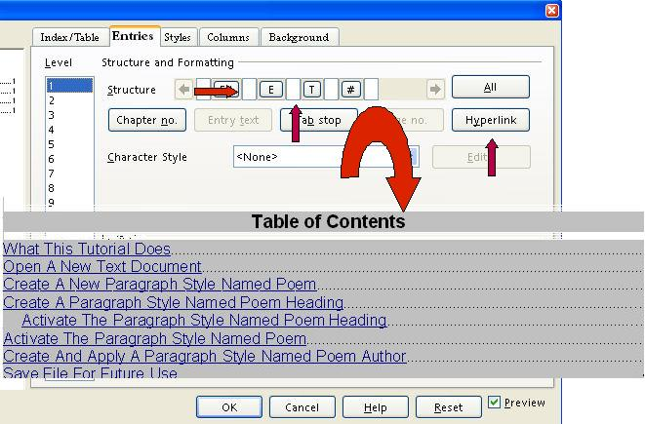

If you have already inserted the Table of Contents
- Place the cursor anywhere in the Table of Contents and right-click. (A menu will appear, ) Click Edit Index/table. (The Insert Index/Table window appears.)
- To make the hyperlinks, click the Entries tab of the window. Click to the left of the E and click Hyperlink. Click after the E and click Hyperlink again. Click All. Click OK.
- After doing Step 2 , you will need to right-click in the Table of Contents (A menu appears. Note: Be careful not to click any of the hyperlinked text in the Table of Contents. Clicking on a blank space between the text and the page numbers is usually best.)
- Click Update Index/Table. (All the headings are in "blue and underlined" and are now "hyperlinks". When you click on them, you will be taken to that section.)

Insert A Footer
- Click Insert > Footer > Default. (A footer appears at the bottom of the page.)
- Type the name of your tutorial and the date. Type Page and press the space bar.
- Click Insert > Fields > Page Number. (The page number appears after “Page”.)
- Optional Additional step: Click Insert > Fields > Page Count. (“Page 1 of 1” appears on the first page of your document. As you add pages, the pages are numbered and the number of pages after “of” increases.

Note
Tutorials are improved by input from users. We solicit your constructive criticism.
E-mail suggestions and comments to tutorialsforopenoffice@yahoo.com For other free tutorials go to: www.tutorialsforopenoffice.org
Edited by Sue Barron

