
Print An Envelope
Table of Contents
Setup The Envelope 1
Print The Envelope 2
This tutorial shows how to print a #10 envelope that is 9.50" wide by 4.13" high..

Setup The Envelope
- Click File > New > Text Document. (The document appears.)
- On the menu bar, click Insert > Envelope. (The window appears.)
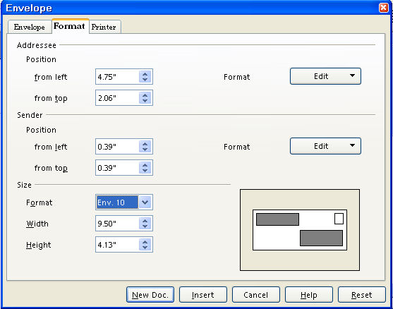
- Click the Format tab. In the Size section, In the Format pull-down menu, select Env. 10. (The correct numbers appear in the “Addressee”, “Sender”, and “Size” sections.)
- The window should appear as above with the numbers already added for the Addressee, (Position: from left and from top) Sender, (Position: from left and from top.) and Size (Format, the Width, and Height.)
- Click on the Envelope tab. Click anywhere within the Addresses dialog box. Add an address of your choice. For example, type the words Bob Smith then press Enter. (the cursor goes down to the next line) type the words 1 Main Street then press Enter. Type the words Denver, Colorado then press Enter. Type the numbers 12345.
- IF you want the envelope to have just the name and address of the person receiving the letter (not have your return address on the envelope), remove the check mark before the word Sender.
- IF you want to add your name and address to the envelope, leave the check mark. Click anywhere within the Sender dialog box then add your name and address.

Print The Envelope
- Click on the Printer tab. (The screen below appears.). Select your printer's Envelope orientation.

- Click on the New Doc button. (An image of how the envelope will be printed will appear on your screen)
- IF you want to change your return address information (Sender) or the addressee information, click in that box and make the changes.
- Have an envelope in your printer feed tray.
- Click File > Print.
Note
Tutorials are improved by input from users. We solicit your constructive criticism. E-mail suggestions and comments to tutorialsforopenoffice@yahoo.com For other free tutorials go to: www.tutorialsforopenoffice.org
Edited by Sue Barron

