
Create A Tutorial
Table of Contents
Standardization 2
Examples Of Standardization 2
Steps In Writing A Tutorial 2
Copy A Tutorial From The Website 2
To Write A New Tutorial 2
Modify The Headings Of Paragraph Styles 2
Modify/Apply The “Title” Paragraph Style 2
Add Paragraphs 3
Modify/Apply Heading 1 Paragraph Style 3
Modify/Apply Heading 2 Paragraph Style 4
Modify/Apply Heading 3 Paragraph Style 4
Paragraph Headings Can Be Numbered Or Unnumbered. 5
Insert A Table of Contents And Add Hyperlinks 5
Create A Table Of Contents 5
Create A Hyperlinked Table Of Contents 5
If You Have NOT Inserted A Table of Contents 6
If You Have Already Inserted The Table of Contents 7
Insert A Footer 8
Close File 8
This tutorial has general background information about tutorials and some information on standardization. Instructions on how to write a tutorial are given.
- Everyone is encouraged to email us tutorials EVEN IF A TUTORIAL IS FAR FROM COMPLETE. A very difficult part of writing a tutorial is the initial concept for the tutorial and then writing the first draft. Other people are available to build upon your draft. The final draft will be given to actual teachers and students who will find any bugs, if any.
- One way to create a tutorial is to download a tutorial and modify that tutorial.
- Most tutorials on this website are step-by-step instructions to do a specific thing in OpenOffice. It is helpful to keep focused on the specific task to be accomplished and add just the needed information. Do not add unneeded information in an attempt to “educate” the student.
- It is important that the tutorial has all the needed information. Just one missing piece of information may prevent the “student” from understanding/completing the “lesson”.
- See the tutorial “How To Use A Tutorial” for specific information on how tutorials are used, how columns are used, and the purpose of putting words in bold.

Standardization
- Standardization is preferred; however, any practical or usable design is welcome.
- Most tutorials are modular. Each section (block of information) has a title centered at the top followed by paragraphs.
- Any section can be copied and pasted into a tutorial you are writing.
- Use Bold to indicate the words that require an action or to call attention to the words.

Examples Of Standardization
- Bold is used so that certain words stand out; for example, words to be clicked or to be typed are in bold.
- This tutorial is written so that each section has a heading (title) centered at the top and followed by paragraphs.
- Parentheses ( ) enclose the explanatory information.

Steps In Writing A Tutorial

Copy A Tutorial From The Website
If you copy a tutorial, you might use the formatting that is already there and even use some of the information.

To Write A New Tutorial

Modify The Headings Of Paragraph Styles
The “Title” Paragraph Style is meant to be the title of the tutorial. The “Heading 1” Paragraph Style is used for the heading of sections. The “Heading 2” and “Heading 3” Paragraph Styles are used for the subheading of sections that give information pertaining to the "Heading 1 Paragraph Style."

Modify/Apply The “Title” Paragraph Style
- Click File > New > Text Document. (The document appears.)
- On the first line of the page, type the name of the tutorial and leave the cursor on that first line.
- Click Format > Styles and Formatting. (The "Styles and Formatting" window appears.)
- Click the Paragraphs Styles icon (if the "Paragraph Styles" menu is not already there). (The "Paragraph Styles" menu appears. The list of words in the window is the names of Paragraph Styles that are available for use with paragraphs.)
- Click on the in the menu box at the bottom of the Paragraph Styles window . Scroll to and select “Chapter Styles”. (The "Chapter Styles” window appears.)
- Right-click Title. (A small menu appears 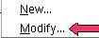 )
- Click Modify. (The "Paragraph Style: "Title" window appears.)
- Click the Alignment tab. In the Options section, click Center. (A dot appears before the word “Center”.)
- Click the Font tab. If it is not already selected/highlighted, click Arial ("Font) > Bold (“Typeface”) > 16pt. (“Size”) > OK.
- In the Styles and Formatting window, double-click Title. The title of your tutorial will move to the center of the line.

Add Paragraphs
- Press the Enter key twice. (When any Paragraph Style with the word Title in its name is activated and the Enter key is pressed, the cursor stays in the center of the page and the Paragraph Style, Subtitle is activated. If you choose not to use a Subtitle, click Enter twice to activate the Text body Paragraph Style and then the cursor will move down two lines and the Paragraph Style named Text body will be activated. The font name is “Arial”, the font size is 12 and the Bold icon no longer has a white background or another color depending upon your settings and is not in use.)
- Type the words, There are two methods to create a tutorial. One method is to copy the tutorial from the website and modify it. Another method is to write the tutorial following the steps given in this tutorial. (Because the Paragraph Style named “Text Body” was activated when “Enter” was pressed twice, the font size is 12 and the words are not in bold. The paragraph you just typed are different than the words “My Tutorial”. The Paragraph Style, “Title” is in effect for “My Tutorial” while the Paragraph Style “Text body” is in effect for the paragraph you typed.)
- Press the Enter key. (The cursor moves down two lines. The Paragraph Style “Text body” stays activated.)
- Type the words, Two reasons for tutorials to be standardized are a module may be used in another tutorial and instructions for the same task are presented in the same manner in all the tutorials.
- Press the Enter key.

Modify/Apply Heading 1 Paragraph Style
- Press Enter.
- Type the name of the section heading. For this lesson type the words, Section Heading.
- In the Paragraph Styles window, right-click on Heading 1. (A small menu appears.)
- Click Modify. (The “Paragraph Style: Heading 1” window appears.) Click the Alignment tab. In the “Options” section, click on the word Center. Click Font tab > Font > Arial > Typeface > Bold > Size > 16 > Close.
- Double-click Heading 1. (The words, "Section Heading", moves to the center, become smaller, and is darker. The Paragraph Style “Heading 1” automatically applies the font name, "Arial", the font size, "16", and is in "Bold". )

Modify/Apply Heading 2 Paragraph Style
- Press Enter.
- Type the name of the subheading. (For this lesson type the word, Subheading.)
- Right-click on Heading 2. (A small menu appears.)
- Click Modify. (The “Paragraph Style: Heading 2” window appears.) Click the Alignment tab. In the “Options” section, click on the word Left. Click the Font tab > Font > Arial > Typeface > Bold > Size > 14 > Close.
- Click the Indent & Spacing tab. In the Indent section, in the Before text dialog box, type .50. Click OK.
- Double-click Heading 2. (The word, "Subheading", becomes darker. The Paragraph Style “Heading 2” automatically applies the font name, "Arial", the font size, "14pt", is indented ½ inch and is in "Bold".)

Modify/Apply Heading 3 Paragraph Style
- Type the name of the subheading. (For this lesson type the words, Another Subheading.)
- Right-click on Heading 3. (A small menu appears.)
- Click Modify. (The Paragraph Style: Heading 3 window appears.)
- Click the Alignment tab. In the “Options” section, click Left.
- Click the Font tab. If it is not already selected/highlighted, click Arial ("Font) > Bold ( “Typeface”) > 14 pt. (“Size”) > OK.
- Click the Indent & Spacing tab. In the Indent section, in the Before text dialog box, type 1.0. Click OK.
- Double-click Heading 3. (The words, "Another Subheading", are in bold. The Paragraph Style “Heading 3” automatically applies the font name, "Arial", the font size, "14", is indented 1 inch and is in "Bold".)

Paragraph Headings Can Be Numbered Or Unnumbered.
- Click before the word, Subheading.
- On the Formatting toolbar, click on the Numbering On/Off,  icon. (A number "1" appears before the heading, "Subheading".)
- Click on the Numbering On/Off icon again. (The number "1" is no longer there.)

Insert A Table of Contents And Add Hyperlinks
If you would like to do so, you may create a Table of Contents for your tutorial and insert a footer in your tutorial.

Create A Table Of Contents
- After completing your tutorial, click on the last letter in the last word in the title which is the first line of the tutorial. The flashing cursor appears just after the last letter of the last word.
- On the menu bar, click Insert. Click Indexes & Tables. In the menu, click Indexes & Tables. The “Insert Index/Table” window appears.
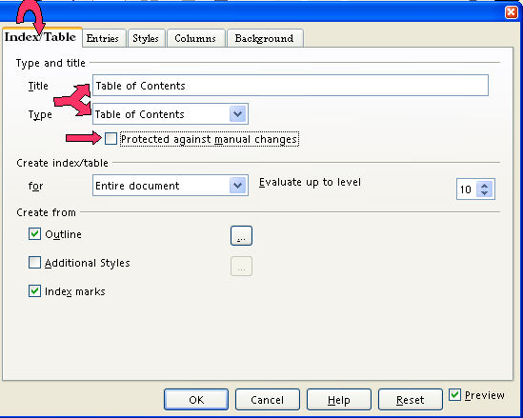
- Select the Index/Table tab, if it is not already selected. In the “Type” dialog box , select Table Of Contents, if it is not already selected. Uncheck Protected against manual changes. Click OK. A Table of Contents appears at the beginning of your tutorial.

Create A Hyperlinked Table Of Contents
When a word(s) in the table of contents is clicked, the cursor will go to where that information is found. For example. “Add Hyperlinks to the Table of Contents” will be in the table of contents of this tutorial. In the table of contents when the words “Add Hyperlinks to the Table of Contents” are clicked, the cursor will go to this section on this page.

If You Have NOT Inserted A Table of Contents
- Click after the last word in the title of the document. Select the Index/Table tab, if it is not already selected. In the “Type” dialog box , select Table Of Contents, if it is not already selected. Uncheck Protected against manual changes. Click OK. The Insert Index/Table window appears.

- To make the hyperlinks, click the Entries tab of the window, click to the left of the E and click Hyperlink, and click after the E and click Hyperlink again. Click All. Click OK. The "Table "of Contents appears. All the headings are in "blue and underlined" and are now "hyperlinks". When you click on them, you will be taken to that section.

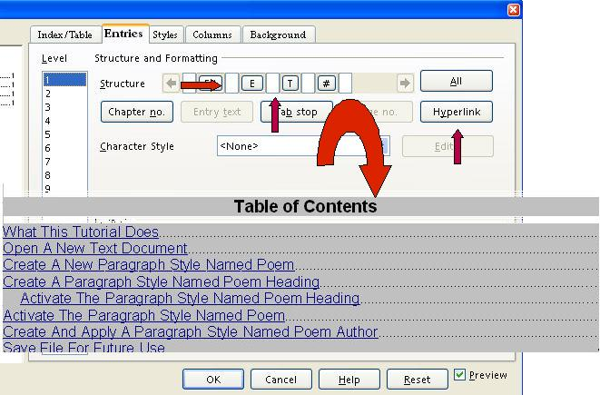

If You Have Already Inserted The Table of Contents
- Place the cursor anywhere in the Table of Contents and right-click. click Edit Index/table. A menu will appear,
The Insert Index/Table window appears.

- To make the hyperlinks, click the Entries tab of the window, click to the left of the E and click Hyperlink, and click after the E and click Hyperlink again. Click All. Click OK.
- After doing Step 2 , you will need to right-click in the Table of Contents. (A menu appears. Note: Be careful not to click any of the hyperlinked text in the Table of Contents. Clicking on a blank space between the text and the page numbers is usually best.)
- Click Update Index/Table. (All the headings are in "blue and underlined" and are now "hyperlinks". When you click on them, you will be taken to that section.)

Insert A Footer
If you would like to do so, you may insert a footer in your tutorial.
- Click Insert > Footer > Default. A footer appears at the bottom of the page.
- Type the name of your tutorial and the date. Type Page and press the space bar.
- Click Insert > Fields > Page Number. The number “1” appears after “Page”.
- If you like, you can press the space bar after the number, type of and click Insert > Fields > Page Count. “Page 1 of 1” appears on the first page of your document. As you add pages, the pages are numbered and the number of pages after “of” increases.

Close File
Click File > Close > Discard. (When a file has been changed, you will see the message below. The document is no longer on the screen.)
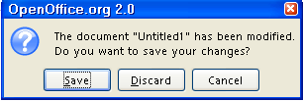

Note
Tutorials are improved by input from users. We solicit your constructive criticism. E-mail suggestions and comments to tutorialsforopenoffice@yahoo.com For other free tutorials go to: www.tutorialsforopenoffice.org
Edited by Sue Barron and George Hans

