
Authors Template Instructions
Table of Contents
Download And Print This Tutorial 1
Download And Open The Authors Template 1
Modify the Footer 2
Background Information 2
Below Is The Way The Headings Will Appear In Your Tutorial 3
Heading 1 3
Heading 2 3
Heading 3 3
Heading 4 3
Add A Heading 1 3
Download And Save "Authors Template" 3
Use The Authors Template To Write Your Tutorial 4
Create A Table Of Contents 4
Create A Table Of Contents 4
Add Hyperlinks To The Table Of Contents 4

The purpose of this tutorial is to provide instructions for using the Authors Template.

Download And Print This Tutorial
Keep a printed copy of this tutorial available as you do this tutorial.
- Click .> Internet. Click anywhere in the box that has words that begin with “http://”. Press the Delete key. (The box now has no content.)
- In the box type www.TutorialsForOpenOffice. org (Do NOT put a space before org) (The Home Page of our website appears on your screen)
- Under “Our Tutorial Offerings” click Writer. (The “WRITER (word processing) Tutorials” page appears)
- Scroll down to “Chapter 9”. At “Lesson 4”, click on the OO for that lesson.
- Select Open with. > Click OK > Print the tutorial.

Download And Open The Authors Template
- IF you are still on the “WRITER (word processing) Tutorials” page, at the words “Click here to download the template itself”, click on the here . Select Open with: Click OK
- IF you are not on our website, click > Internet. Click anywhere in the Search box (The box has words that begin with “http://”.) Press the Delete key. (The box becomes empty.)
- In the box type www.TutorialsForOpenOffice. org (Do NOT put a space before org) (The Home Page of our website appears on your screen)
- Under “Our Tutorial Offerings” click Writer. (The “WRITER (word processing) Tutorials” page appears)
- Scroll down to Chapter 9. At “Lesson 4”, click on the here at the words “Click here to download the template itself”. Select Open with: Click OK.
Add A Title
The X on the template is where the title of your tutorial will be placed.
- Press the Delete key to delete the X.
- Type the name of your tutorial. For this tutorial, type My Tutorial.
- Press the Enter key. (The cursor moves down two lines and is at the left margin of the page. The text body is in effect)

Modify the Footer
- Add the name of your tutorial to the Footer. (Click on the Footer. > Delete the name that is in the Footer then add the name of your tutorial.)
- Delete the Date Field. (In the Footer, click anywhere on the date then press the Delete key.)
- Add today's date. (Click Insert > Fields > Date)

Background Information
A Heading is used at the top of one or more paragraphs. “Background Information” and “Title”, above, are examples of Headings.
Four different Heading are used in our tutorials.
- The “Heading 1” is centered and is used for major sections.
- A “Heading 2” is Aligned Left and indented ½ inch. It is used as a sub-section under a Hading 1.
- A “Heading 3” is Aligned Left and indented 1 inch. It is used for a sub-section under a Heading 2.
- A “Heading 4” is Aligned Left and indented 1 ½ inch. It is used for a sub-section under a Heading 3.

Below Is The Way The Headings Will Appear In Your Tutorial

Heading 1
(one or more paragraphs will go here)

Heading 2
(one or more paragraphs will go here)

Heading 3
(one or more paragraphs will go here)

Heading 4
(one or more paragraphs will go here)

Add A Heading 1
- By doing the “Title” part of this tutorial, above, your cursor is at the beginning of a new paragraph and the “text body” style is in effect.
- In the “Apply Style” pull-down menu box, select Heading 1. (The cursor moves to the center of the line)
- Type the Heading. For the purpose of this tutorial, type My first Heading 1.

Download And Save "Authors Template"
- Click the blue underlined HERE in the beginning of this tutorial to download the Author's Template.
- Click File > Open. (Find "Author's Template" where you downloaded it.)
- Click File > Templates > Save. (The “Template” window appears.)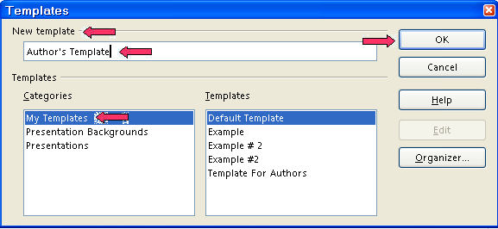
- In the New template dialog box, type the name for the template. Use any name that will help you remember it. Author's Template is used here.
- Click OK. (Your template is named “Author's Template” or another name of your choice and saved in the "Templates" folder. The “Template” window closes.)

Use The Authors Template To Write Your Tutorial
- Click File > New > Templates and Documents. (The “Templates and Documents”window appears.)
- Click My Templates. (The “Templates and Documents– My Templates” window appears.)
- Click Author's Template (or the name you chose). Click Open. (A new text document will appear. The cursor is flashing on the X in the "Author's Template." )
- Click File > Save As. (The “Save As:” window appears.) In the Save in: pull-down menu box, click My Documents if it is not already selected. In the Save as type: pull-down menu box, click OpenDocument Text (.odt) (if it is not already selected).
- In the File name: box, type a name of your choice for your tutorial. (The “tutorial” is saved.)
- Write the steps to do something in OpenOffice in a numbered step-by-step format. You have created a great tutorial.

Create A Table Of Contents

Create A Table Of Contents
A Table of Contents is done after you complete your document. The headings and sub-headings in your document become the entries in the Table of Contents.

- Click after the last word in the title of the document, just after the words, My Classes. (The flashing cursor appears after the letter “s”.)
- Click Insert > Indexes & Tables > Indexes & Tables. (The “Insert Index/Table” window appears.)
- Select the Index/Table tab, if it is not already selected. In the “Type” dialog box , select Table Of Contents, if it is not already selected. Uncheck Protected against manual changes. Click OK. (The "Table of Contents" appears under the title of your document.)

Add Hyperlinks To The Table Of Contents
- Place the cursor anywhere in the Table of Contents and right-click. (A menu will appear,) Click Edit Index/table. (The Insert Index/Table window appears.)
- To make the hyperlinks, click the Entries tab of the window, click to the left of the E, click Hyperlink. Click after the E, click Hyperlink again. Click All. Click OK.
- After doing Step 2 , you will need to right-click in the Table of Contents (A menu appears. Note: Be careful not to click any of the hyperlinked text in the Table of Contents. Clicking on a blank space between the text and the page numbers is usually best.).
- Click Update Index/Table. (In the Table of Contents, all the headings are in "blue and underlined" and are now "hyperlinks". When you click on them, you will be taken to that section.)

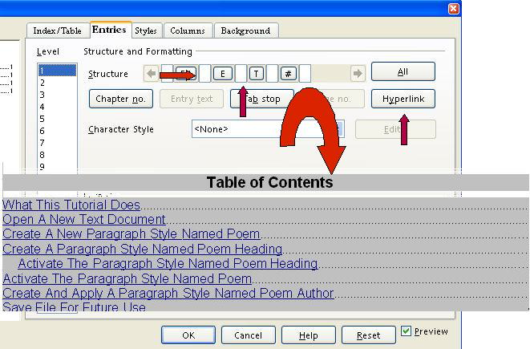

Note
Tutorials are improved by input from users. We solicit your constructive criticism. E-mail suggestions and comments to tutorialsforopenoffice@yahoo.com For other free tutorials go to: www.tutorialsforopenoffice.org
Edited by Sue Barron and George Hans

