WHAT IS IMPRESS?
Table of Contents
Use A Template 1
Save And Close Your Presentation 4
To Watch "My Slide Show” at a Later Time 4
IMPRESS is the presentation feature in OpenOffice. A presentation is a page that can be seen on the computer screen as normal and, with the use of a projector, the page can be seen on the wall or on an external screen. Normally, a laptop is used since it has good portability.
Impress is like a SLIDE SHOW. One page after the other is projected.
A page that is projected is called a SLIDE. The following can be included in a Slide:
- Animation
- 3-D graphics
- Bullets and Numbered Lists
- All the normal stuff that is in a word processor (Writer) such as bold, colors, text alignment, borders, drawing, templates (master slide) , etc.
Notes can be added to a slide that are not projected but can be seen by the presenter.

Use A Template
OpenOffice has two ready-made templates, "Introducing a. New Product" and "Recommendation of a Strategy".
Activity | Explanation
- Click File > New > Presentation > From Template. | Part 1 of Window 1 of the “Presentation Wizard” appears.  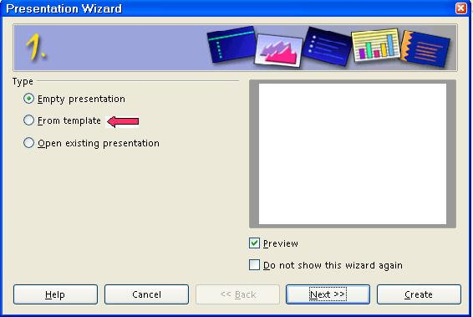
- If not already selected, select Introducing a New Product. Click Next | Part 2 of Window 1 of the "Presentation Wizard" appears.  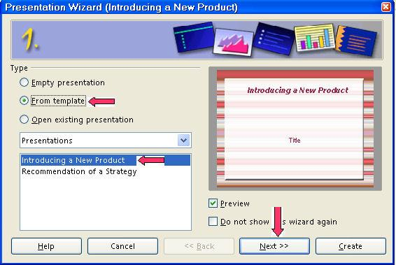
- In the dialog box under Select a slide design, click Presentation if it is not already selected. In the dialog box under Select an output medium, click Slide > Next. | Window 2 of the "Presentation Wizard" appears. Note that "Introducing a New Product" is highlighted.  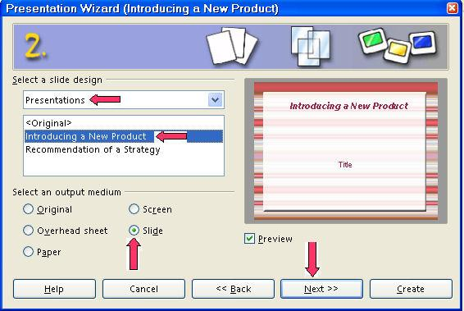  If you prefer another background than the default, under "Select a slide design", click "Presentation backgrounds" and select your choice.
- Under Select a slide transition, use the default for Effect and Speed. Under Select Presentation Type, click Automatic. In the Duration of pages dialog box, type 11 in the seconds place. In the Duration of pause, type 11 in the seconds place. | Window 3 of "Presentation Wizard" appears  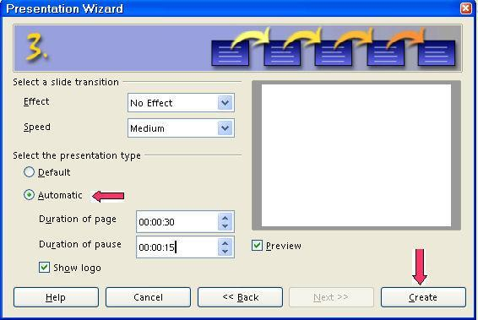  Highlight and type the numbers or use the to select a number.  The format for the numbers is:  00.00.11  00.00.11  The "hours setting" is before the first decimal (period). The "minutes setting" is before the second decimal. The "seconds setting" is before the third decimal.
- Note if you use the default settings, click "Create" and you have your presentation ready for pictures, text, etc. | 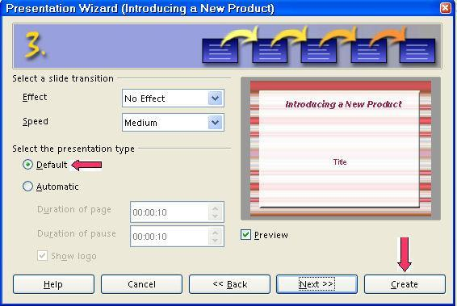
- Under Describe your basic ideas, in the dialog box under What is your name or the name of your company?, type The Save Time Company. In the dialog box under What is the subject of your presentation?, type A New Watch. In the dialog box under Further ideas to be presented, type Use the Stopwatch Function and Use The Date Function. Click Next. | Window 4 of the 'Presentation Wizard" appears.  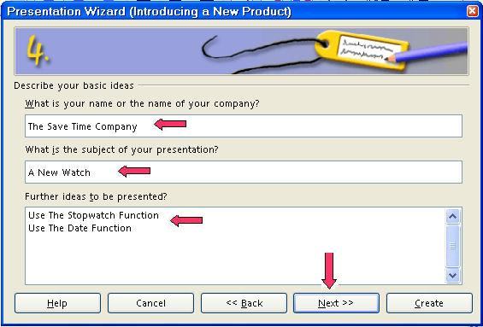
- Under Choose your pages, select what you want in your presentation or use the default settings. Click Create. | Window 5 of the "Presentation Wizard" appears.  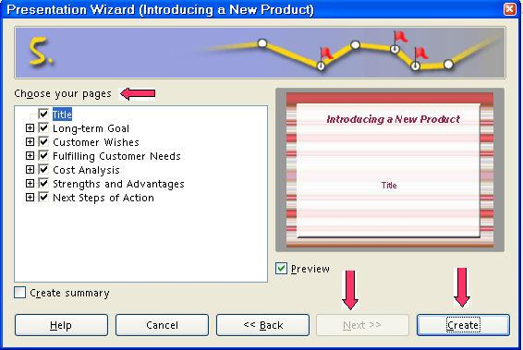  Note: "Next" is grayed. "Create" is the next step.
- Click Slide Transition if it is not already selected. To see your presentation that you just made, click Slide Show. | 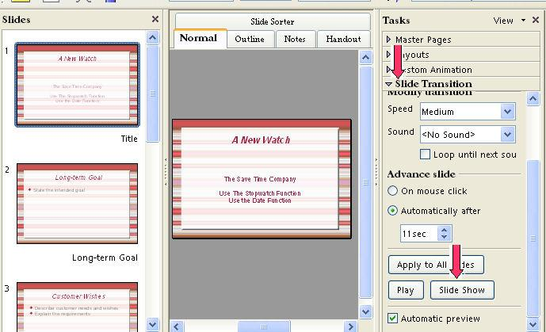

Save And Close Your Presentation
Activity | Explanation
- Click File > Save As. In the Save in: " pull-down menu box, click My Documents (if it is not already selected). In the Save as type:" pull-down menu box, click OpenDocument Presentation (.odp) (if it is not already selected).
- In the File name: box, type My Slide Show .
- Click Save. | " My Slide Show" is saved. The file, "My Slide Show" is still on the screen.
- Click File > Close. | The file, " My Slide Show", is no longer on the screen.

To Watch "My Slide Show” at a Later Time
Activity | Explanation
- Click File > Open. | The "Open" window appears.
- In the menu below the "Look in:" dialog box, click My Documents if it is not already there. In the menu below the File name: dialog box, click My Slide Show. | "My Slide Show" appears on your screen.
- Click Slide Transition if it is not already selected. To see your presentation that you just made, click Slide Show.

Tutorials are improved by input from users. We solicit your constructive criticism.

E-mail suggestions and comments to tutorialsforopenoffice@yahoo.com

For other free tutorials go to: www.tutorialsforopenoffice.org

Edited by Sue Barron

