
Restart A Presentation Automatically

You can make your Impress presentations restart automatically after a specific time which you set. This is useful if you have, for example, a stand set up at a trade show. You might also create a small presentation for use before a main event and have it playing before the event starts.

You make your presentation automatically restart as follows:
Activity | Explanation
- Click on Slide Show – Slide Show Settings. | 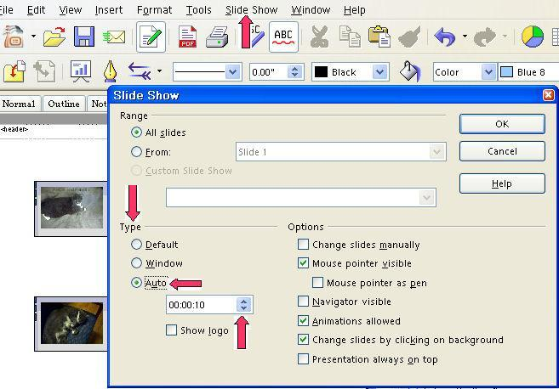
- Under the Type choose Auto.
- Then set the time in Seconds. This will be how long it takes before the slide show restarts.

Note
Tutorials are improved by input from users. We solicit your constructive criticism. E-mail suggestions and comments to tutorialsforopenoffice@yahoo.com For other free tutorials go to: www.tutorialsforopenoffice.org
Edited by Sue Barron

